Strategic Approaches for Sustaining a Competitive Advantage
Student’s Name
Institutional Affiliations

Strategic Approaches for Sustaining a Competitive Advantage
A Comparative Chart of the Strategic Approaches for Sustaining Competitive Advantages
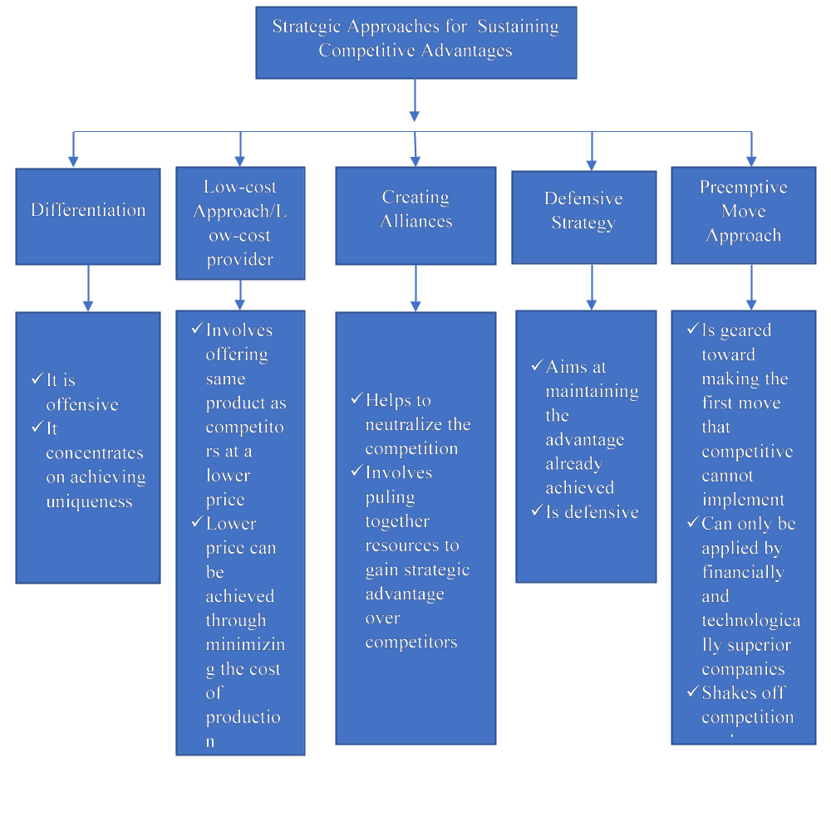
In the business world today. Competition is the order of the day. This means that firms and business organizations compete for supremacy as well as for the customers and markets for their products. This being the case, every organization looking to be successful has to find ways of ensuring that it remains a step ahead of its competitors in terms of winning over the customers and holding onto a particular market segment. This is the only sure way of ensuring that the business organization remains in business and continues with its operations without a threat of being toppled by other competitors in the industry. Therefore, for business to remain a step ahead of their competition, they have to apply approaches that can enable them to sustain competitive advantage in their endeavours. These approaches can be understood from the Michael Porter’s narrow and broad categories of competitive strategies used to achieve competitive advantage in business.
One of the approaches used for sustaining competitive advantage by business organizations is differentiation strategy. As the name suggests, differentiation strategy is where a business organization or firm strives to differentiate itself from its competitors. Differentiation can be done in many ways. For example, an organization can achieve differentiation by conducting research to find out a unique market niche that is not being addressed by its competitors and comes up with products that it then markets to that specific market niche and this way it becomes distinct from its competitors. The competitive strategy is designed from the customer’s perspective and not from the company’s perspective. This strategy also involves a business organization finding a marketable attribute that it has and using it to gain an advantage over its competitors by marketing it more to the target group of consumers.
Low-cost Strategy is another approach that can be used to sustain completive advantage by a business organization. It is also called low-cost leadership. It occurs when a business organization provides the same products as its competitors but at a lower price compared to that of its competitors. This enables the organization or firm to gain an advantage over its competitors in terms of winning more customers and therefore enjoying more sales than its competitors. Low unlike differentiation, a low-cost strategy can be achieved by minimizing on the production costs through the application of efficient and effective production procedures. Costs can also be lowered by using sophisticated technology that minimizes the cost of production.
Creating alliances is another approach used to sustain competitive advantage. This involves entering into alliances with other organizations in the form of joint ventures that help the organization to expand and enjoy economies of scale that helps the organization to deal with the competition in the market. However, alliances should not be confused with collusion. Collusion is where different organizations connive to control prices in the market. On the other hand, alliances are leaned towards joint ventures where organizations pull together resources and gain mileage and exposure in business at the expense of other competing organizations. Unlike differentiation and low-cost strategies, alliances are seen as a more defensive approach as opposed to the offensive approaches in differentiation and low-cost strategies.
Another approach of sustaining competitive advantage is the defensive strategy which just like the alliance strategy is also defensive, this strategy involves the business to further distance itself from the competition by maintaining the competitive advantage that it already has. It is therefore used to keep the competitive advantage in place once they have been gained.
Last but not least, preemptive move strategy. This is one of the approaches used to sustain competitive advantage by a business organization. It is only used by technologically and financially superior companies and involves obtaining the first mover advantage, which the competitors are unable to duplicate or counter.
I have worked with Samsung and for this company, I would suggest them to use the preemptive move as an approach to sustaining competitive advantage. This is because currently, there are many other competitors that are trying to apply all the other strategies and therefore, the only way to sustain the competitive advantage that Samsung already has is to obtain an advantage by making the first move as a financially and technologically superior organization which other competitors in the smartphone network cannot implement. Given a chance, I would make a change to the strategic competitive strategy by applying defensive sustainable advantage strategy that will enable the company to continue having the competitive advantage that it has already gained over the years.

